MINI PROJECT REPORT

On

**ONLINE SHOPPING**

**SYSTEM**

**GIUDED BY:**

Ms. MANU BALI

**Submitted By:**

ADARSA SWAIN(58)

SHAIK GAYAZUDDIN

RAMISETTI SAI

**B.TECH DEGREE**

In

COMPUTER SCIENCE &ENGINEERING

LOVELY PROFESSIONAL UNIVERSITY

PHAGWRA

ABSTRACT

This a small scale project based on online shopping website This project based on how to accomplish online shopping website to buy their own products on online websites.

This project is an attempt to provide the advantage of online shopping to customers of a real shop. It help us to buying the product in the shop anywhere in the world .

Thus you can buy your product by sitting at your own house .This is the best way to get to save your time by not going to any place and get product this project is a effective way to get your value for money.

This is online portal to surprise that can access by you any part of world .

Conservative way to get your product in time within the best time it just a value for money things to get your desire one in few days without any obstacle or hurdles.

SCREENSHOT OF THE MODULE

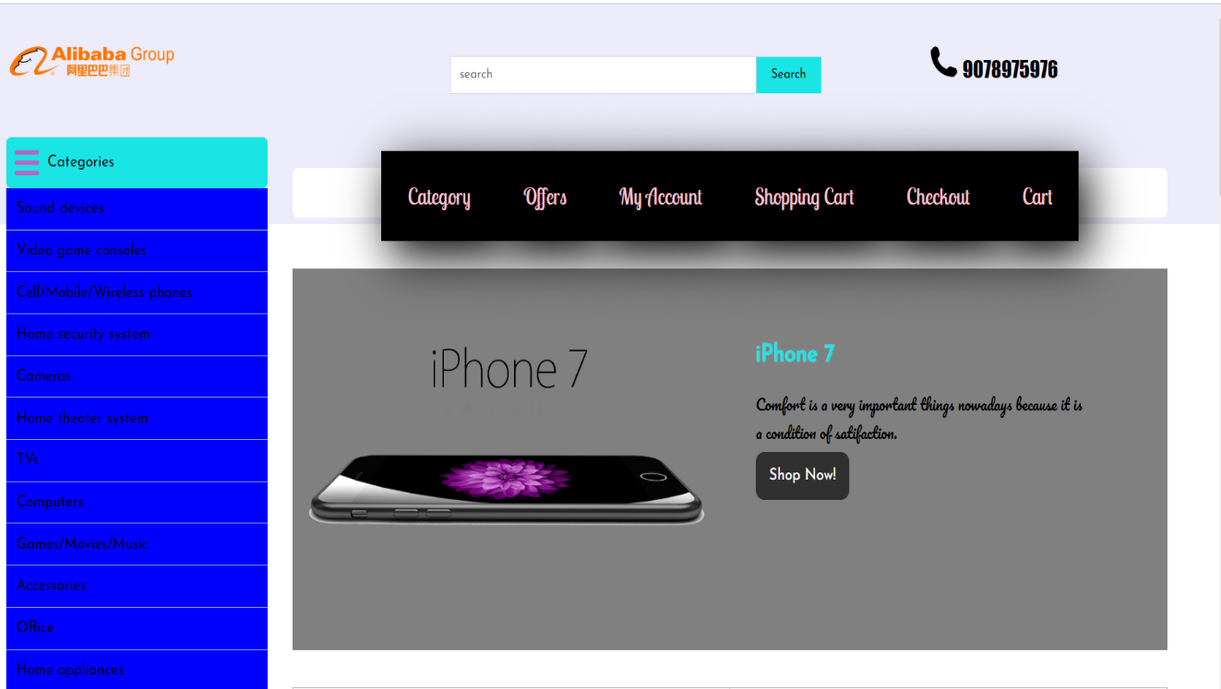 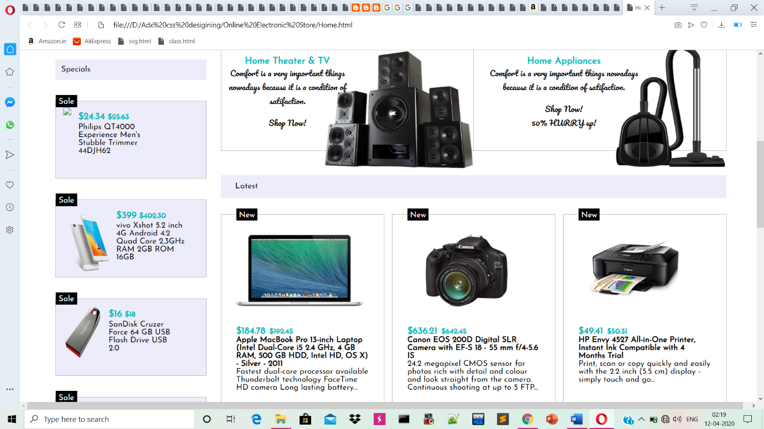

FLOW CHART OF THE MODULE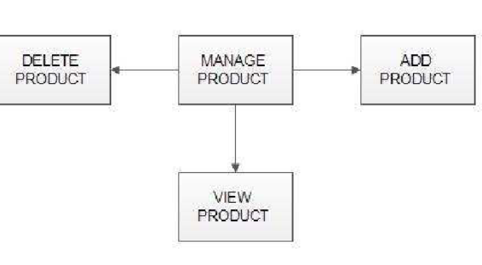

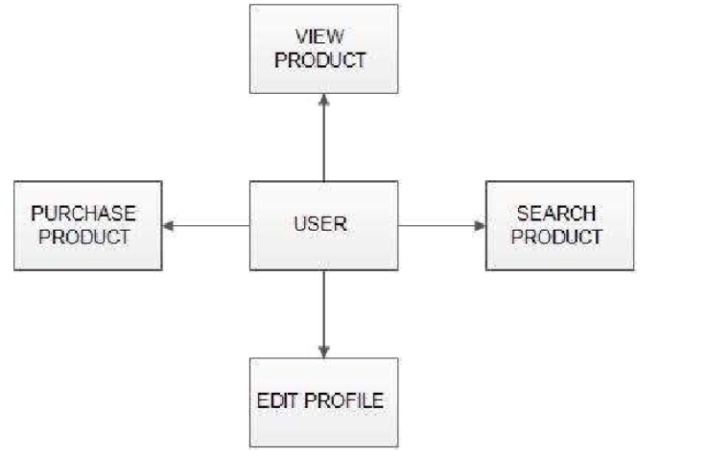

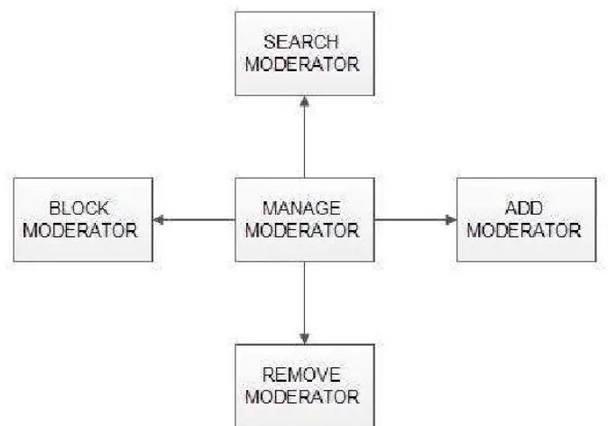

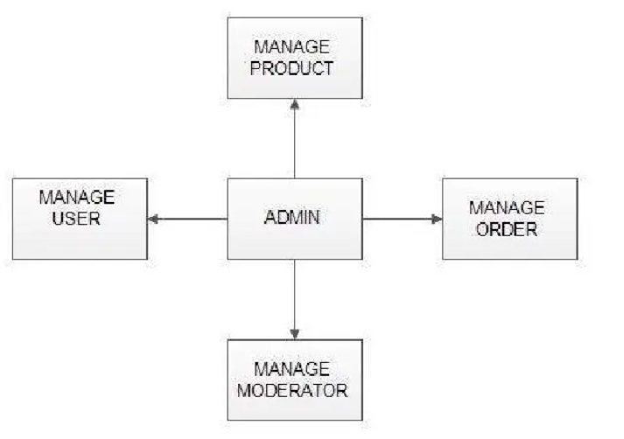

DESCRIPTION



This part is developed by Adarsh swain and Seikh gyazzudin



This part developed by Adarsh and saikumar

MODULE

The system consists of the following modules :

* **Master Maintenance :**

This module consists of information about the products and services. This includes two sub-modules, **Product master** and **Price master**.

* **Product master** includes the information about particular product, such as product number, item, name, category, images of products, description, features, and constraints of products. All these will be entered to the database through product master and hence made available in the website. In Other words product master is the admin area for the vendors/sellers where they can put information about their products which are to be displayed in the website.
* **Price master** deals with the cost of the product, discounts applicable for the particular product of a vendor/seller.
* **Transactions :**

In this module, management of shopping cart is done. This module will add the bought item to the shopping cart, where all items that are to be purchased can be reviewed once again after the item is bought from the cart. Payment will be done on Delivery of the items ( Cash On Delivery).

* **Reporting :**

In this module all reports will be generated. Whenever a item is sold, or customer orders a product, its vendor should be sent an alert via email immediately so that he can ship that item soon.

This module has 3 sub modules; **Stock Reports**, **Order Reports** and **Delivery Reports**.

* **Stock Report** will produce reports of the quantity of the products available and product status.
* **Order Report** will have the list of products ordered and the customer details who have bought that product, which are undelivered.
* **Delivery Reports** will generate products list, which are delivered to customers.
* **House Keeping :**

This module takes care of data which are older than a certain period. It will allow the vendor to archive the reports generated or transaction and business history reported by Reporting module.

**6. Future scope of the Project :**

* Most generic consumer to consumer e-commerce website,which covers almost all possible categories,with 2 level listing.
* Maximize benefits and minimize the disadvantages of a common e-commerce website.
* User friendly, Vendor friendly environment.